## Implementation

**Full Adder** Implementation (Code and RTL Viewer):

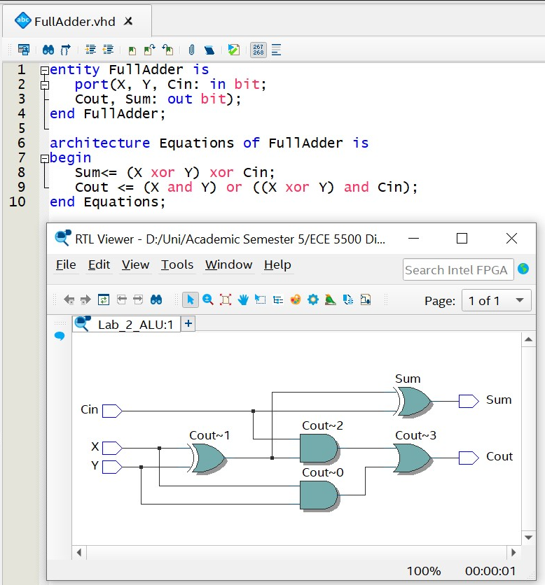

8-bit **Adder** and **Subtractor** Implementation (Code and RTL View):

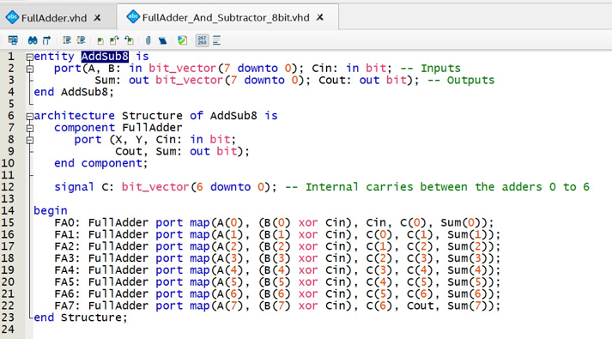

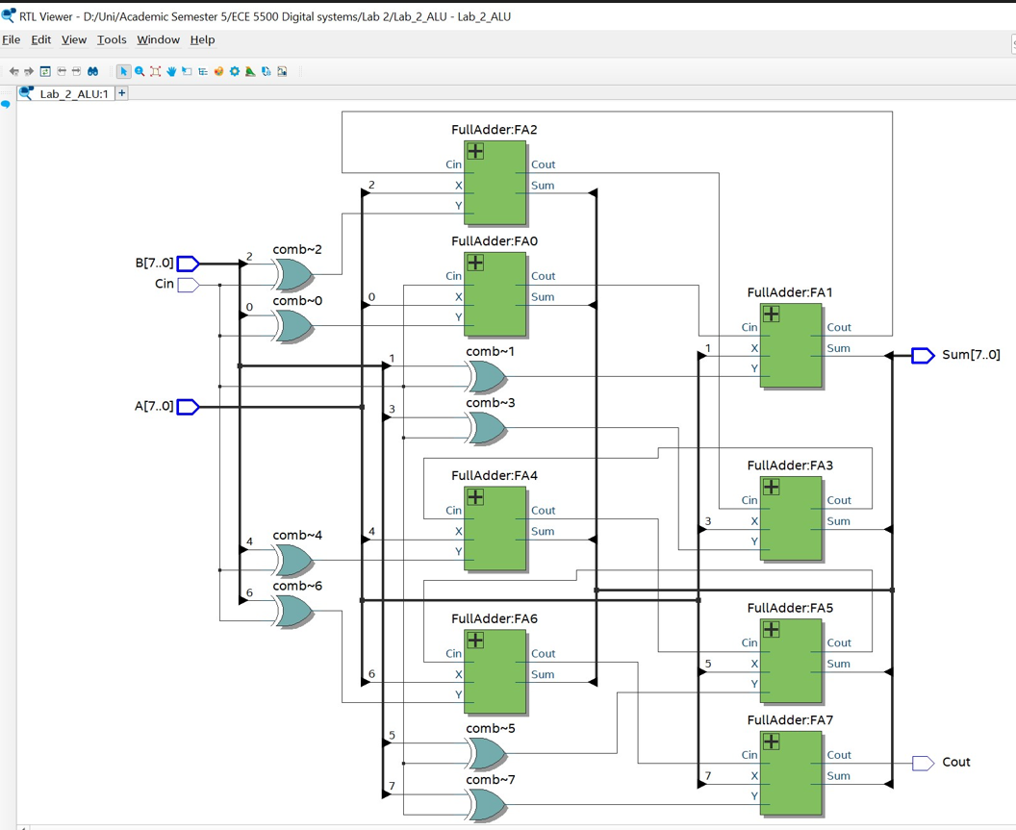

**MUX** (Implementation and RTL View):

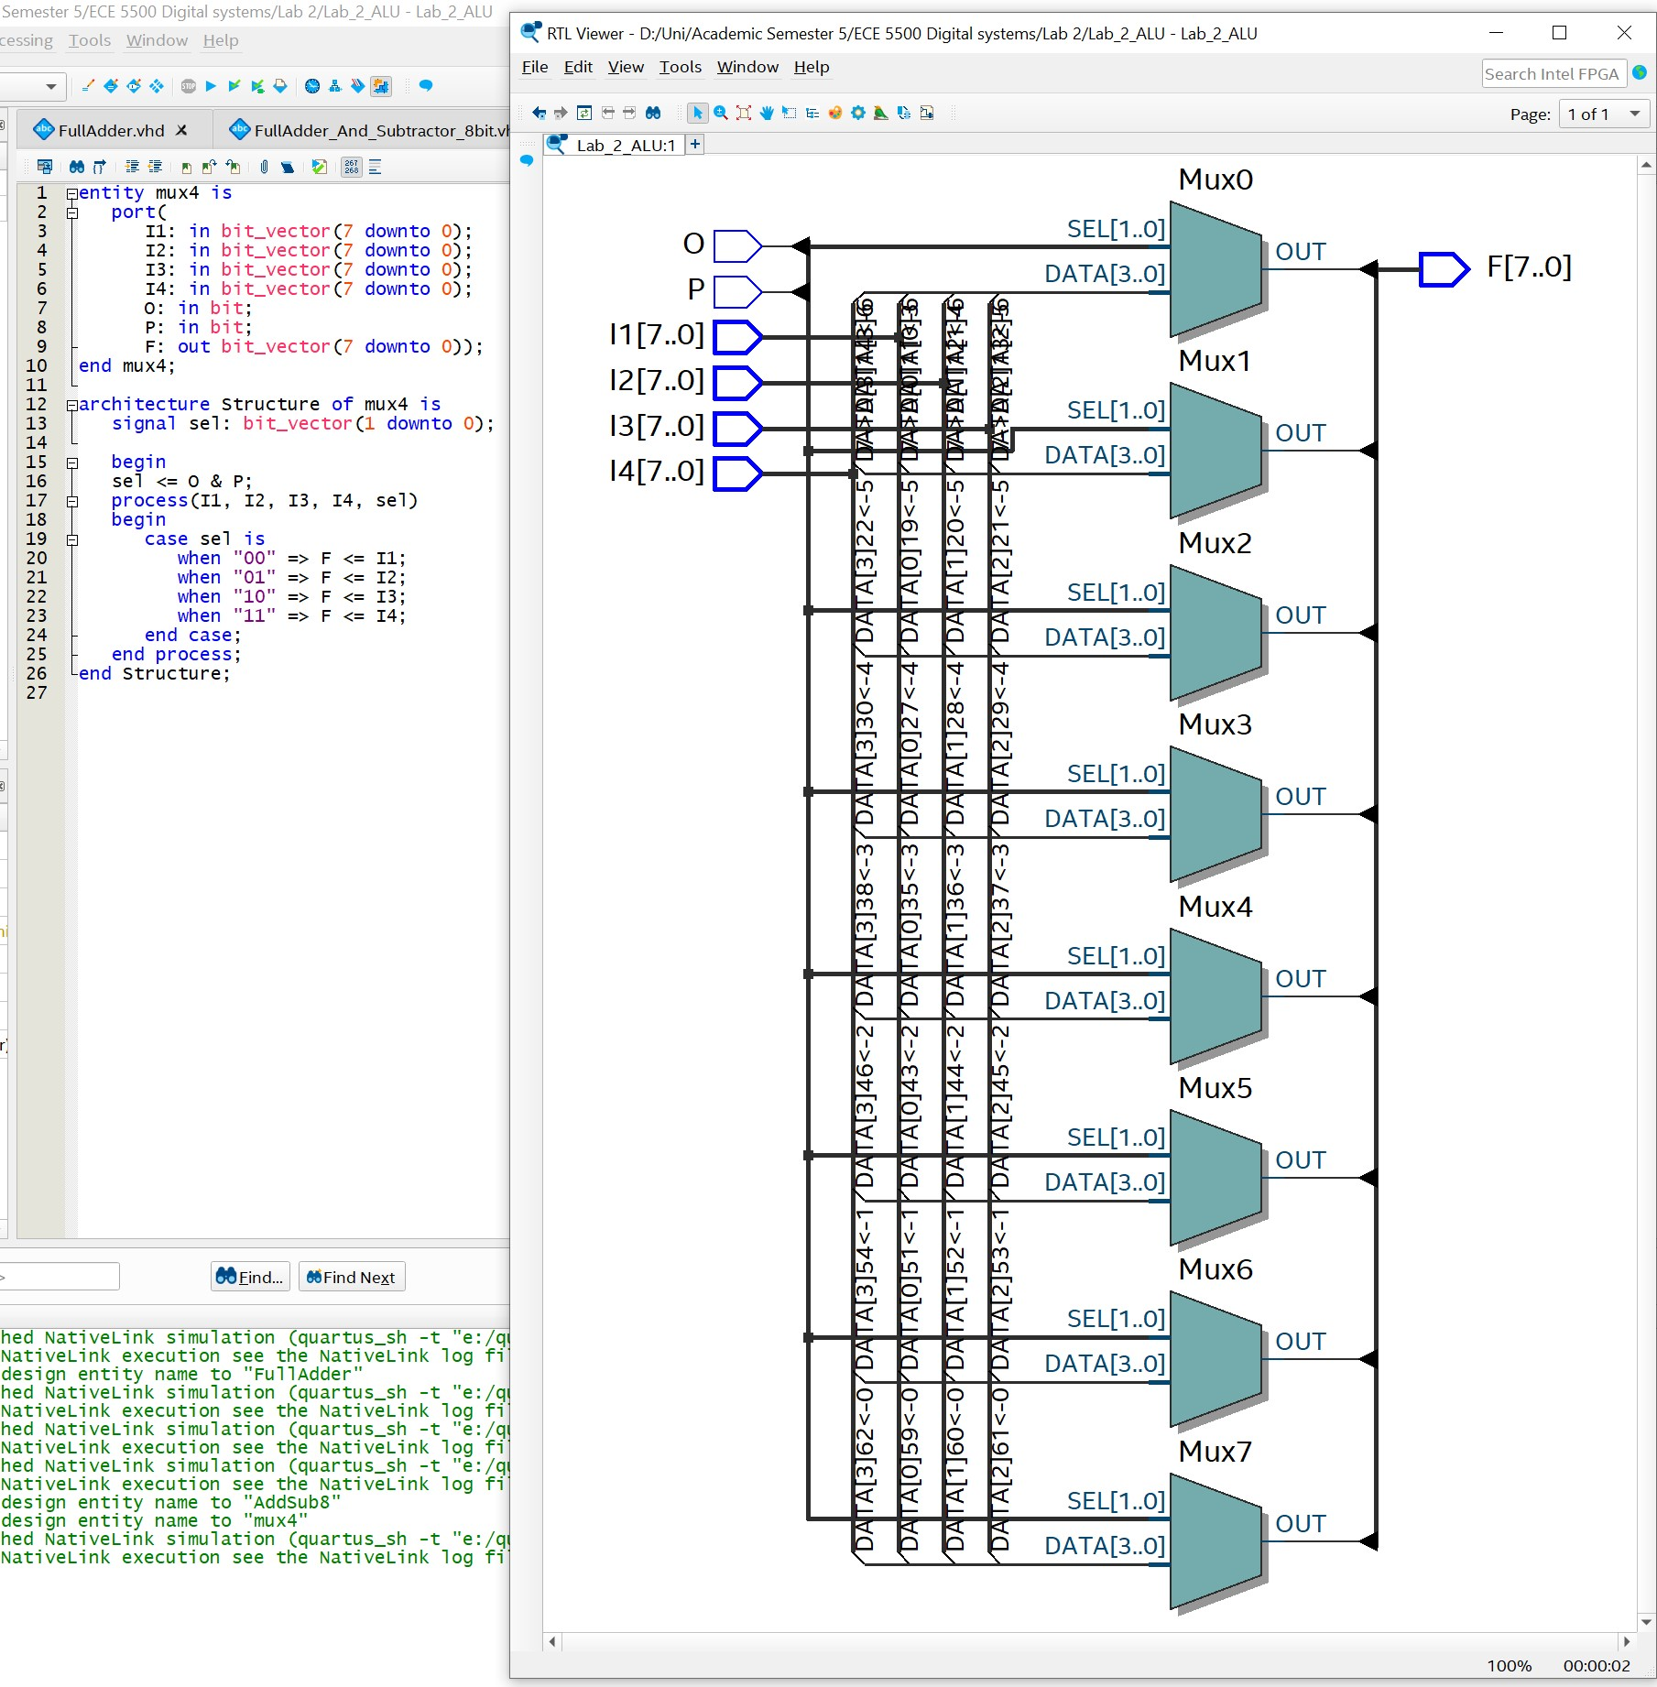

Top Level **ALU** (Implementation and RTL view):

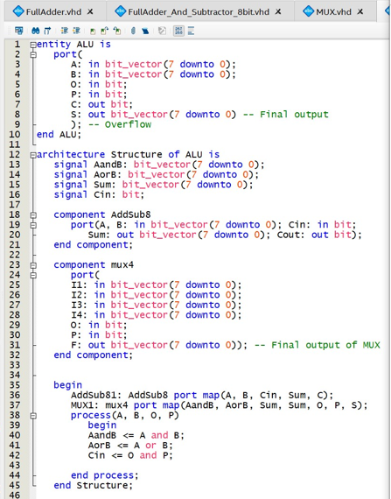

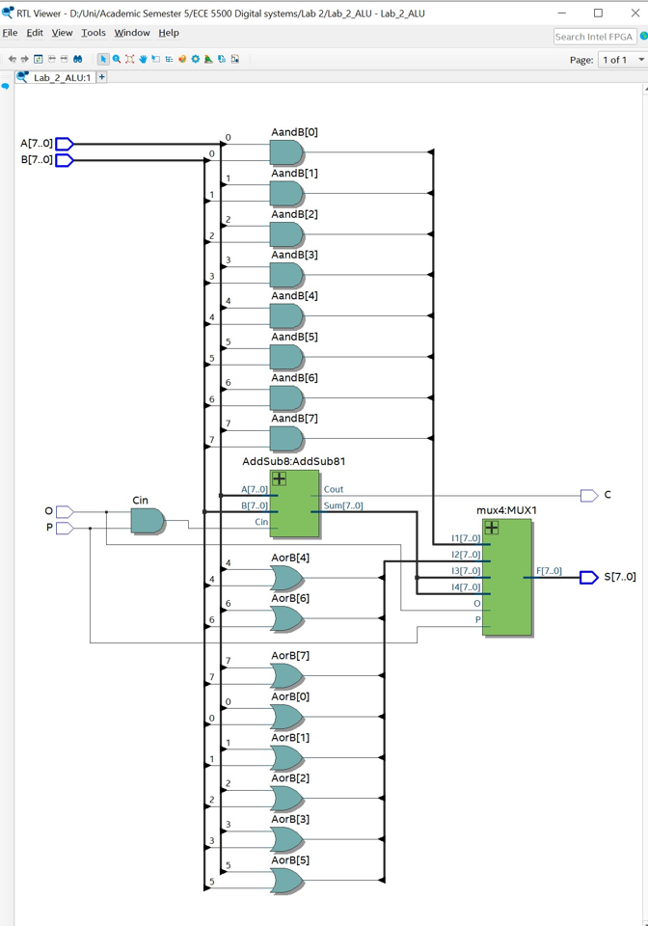

## Testing the ALU:

**1. Testing AND functionality by using O P as 0 0.**

A = 10101010

B = 01010101

Output (S) = 00000000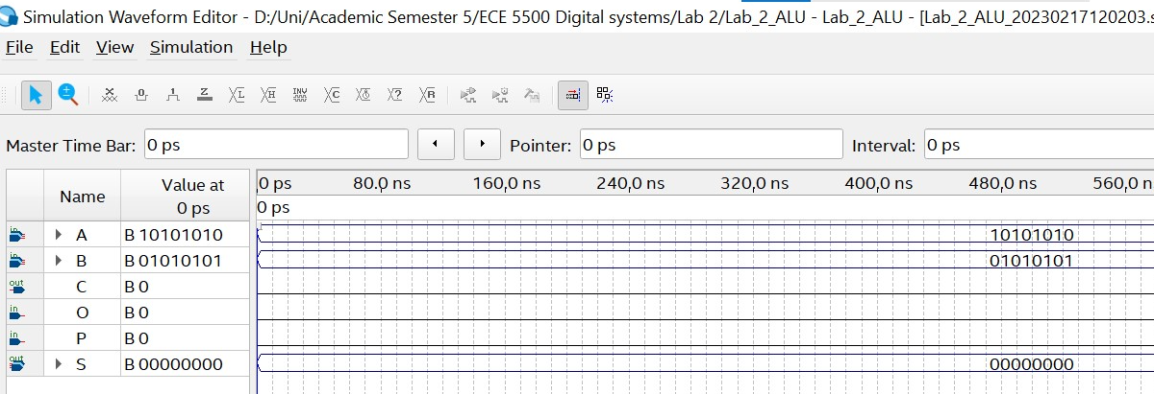

**2. Testing OR functionality by using O P as 0 1.**

A = 10101010

B = 01010101

Output (S) = 11111111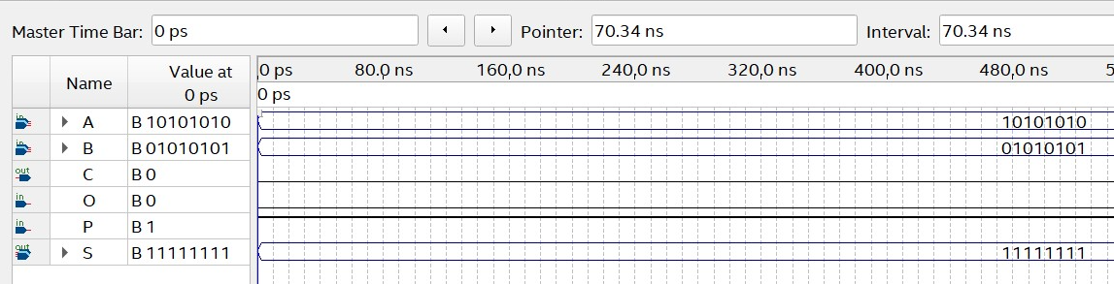

**3. Testing Addition functionality by using O P as 1 0**

A = 10101010

B = 11010101

Output (S) = 01111111

Overflow(C) = 1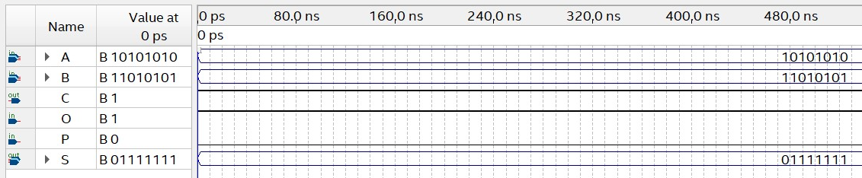

Addition done:

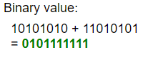

**4. Testing Subtraction functionality using O P as 1 1.**

A = 10101010

B = 11010101

Output (S) = 01111111

Overflow(C) = 0

2’s complement subtraction done: